Our chosen topic shall be food and beverage information provided by the USDA Agricultural Research Service. The food and beverage dashboard shall give the user the option to search any food or beverage to their liking with the nutritional facts and graphical kcal macro and micro information. A comparison page shall be included were you can compare to different food/beverages and visually see the macro/micro nutritional differences. A gauge shall also display how much percentage your daily value is impacted based on the food/beverage and quantity selected (adding macros: carbs, protein, and fat and converting to calories).

Sources:

* [***Food & Nutrition Database For Dietary Studies***](https://www.ars.usda.gov/northeast-area/beltsville-md-bhnrc/beltsville-human-nutrition-research-center/food-surveys-research-group/docs/fndds-download-databases/) FNDDS is a database that provides the nutrient values for foods and beverages reported in What We Eat in America, the dietary intake component of the National Health and Nutrition Examination Survey.
* [***% Daily Value***](https://www.accessdata.fda.gov/scripts/InteractiveNutritionFactsLabel/pdv.html) The % Daily Value (%DV) shows how much of a nutrient is in one serving of the food. The %DVs are based on the Daily Values for key nutrients, which are the amounts (in grams, milligrams, or micrograms) of nutrients recommended per day for Americans 4 years of age and older. The %DV column doesn’t add up vertically to 100%. Instead, the %DV is the percentage of the Daily Value for each nutrient in one serving of the food.

Inspiring visualizations:

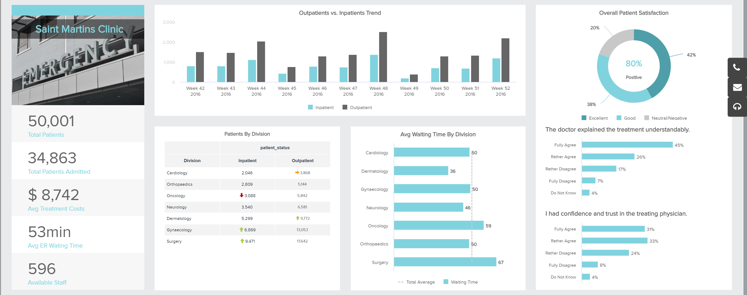

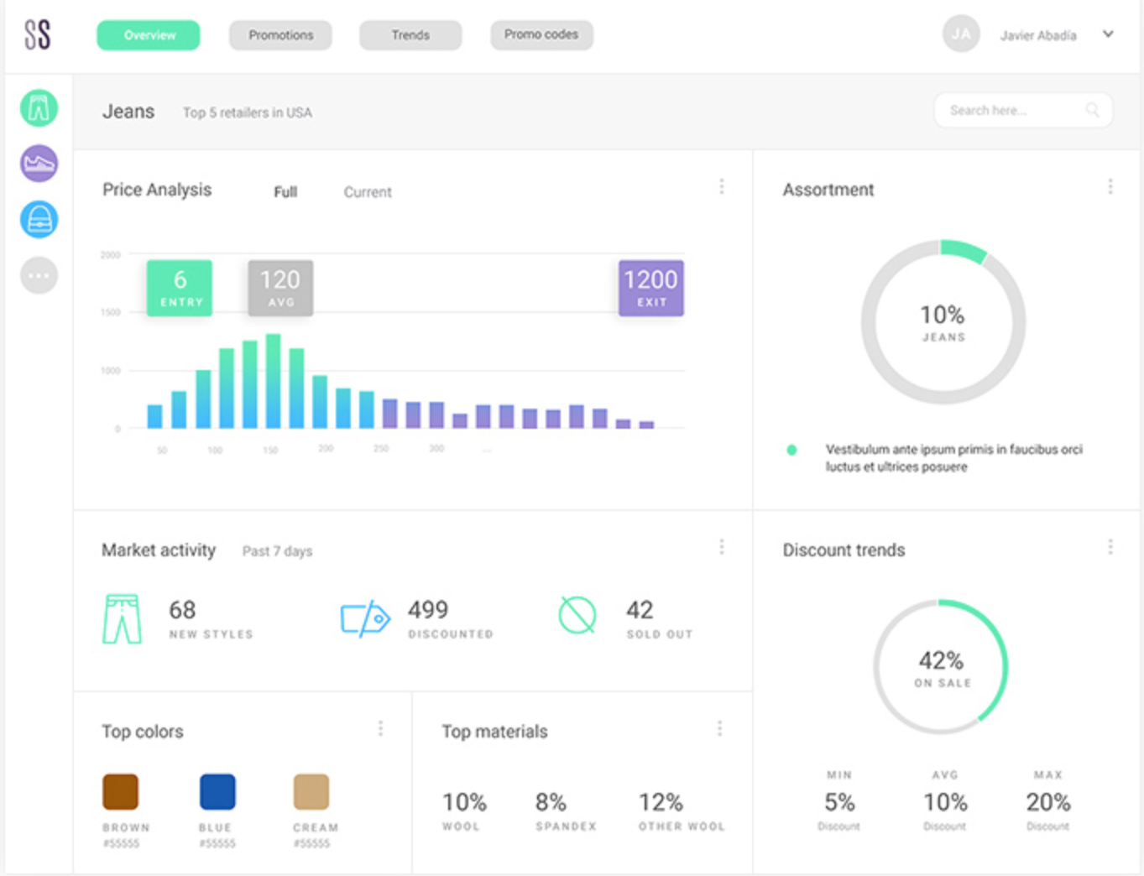

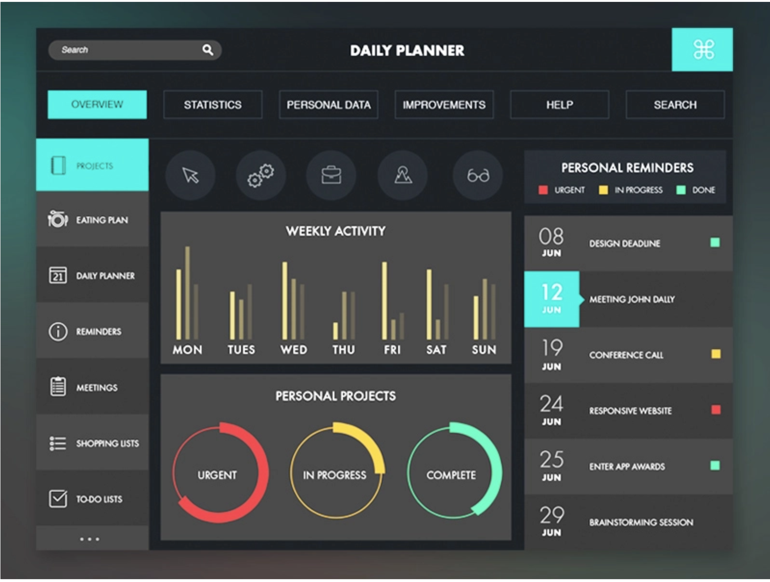

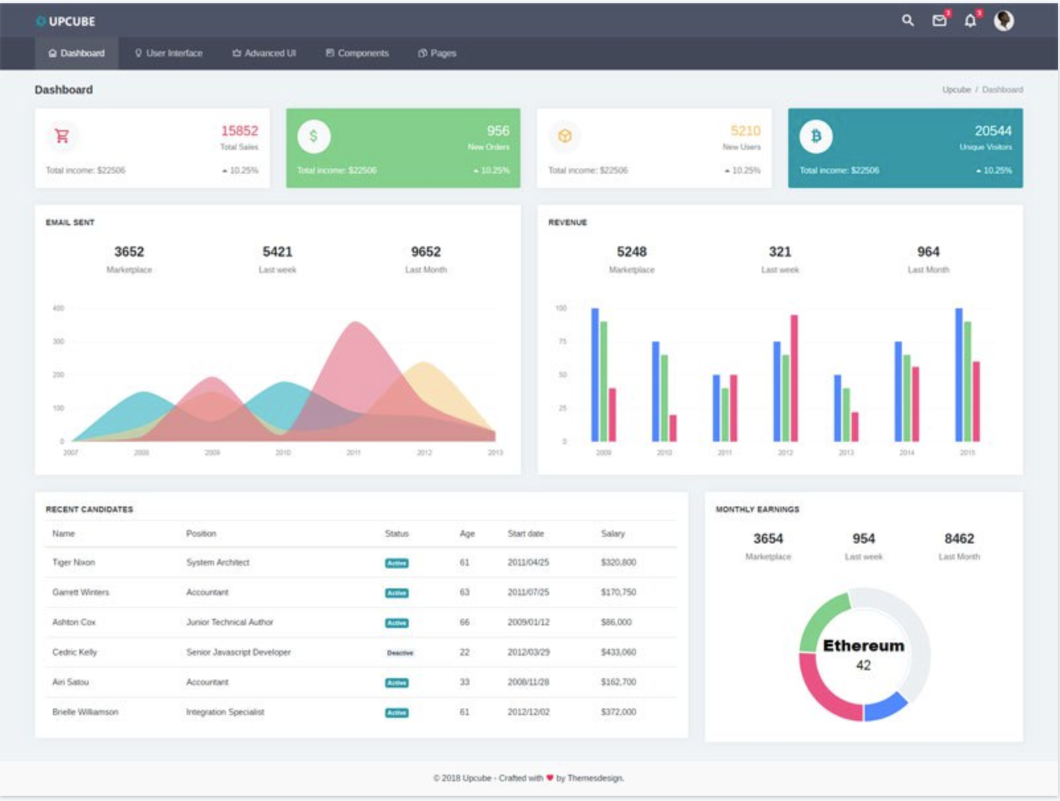

Food and Beverage Dashboard Mockup:



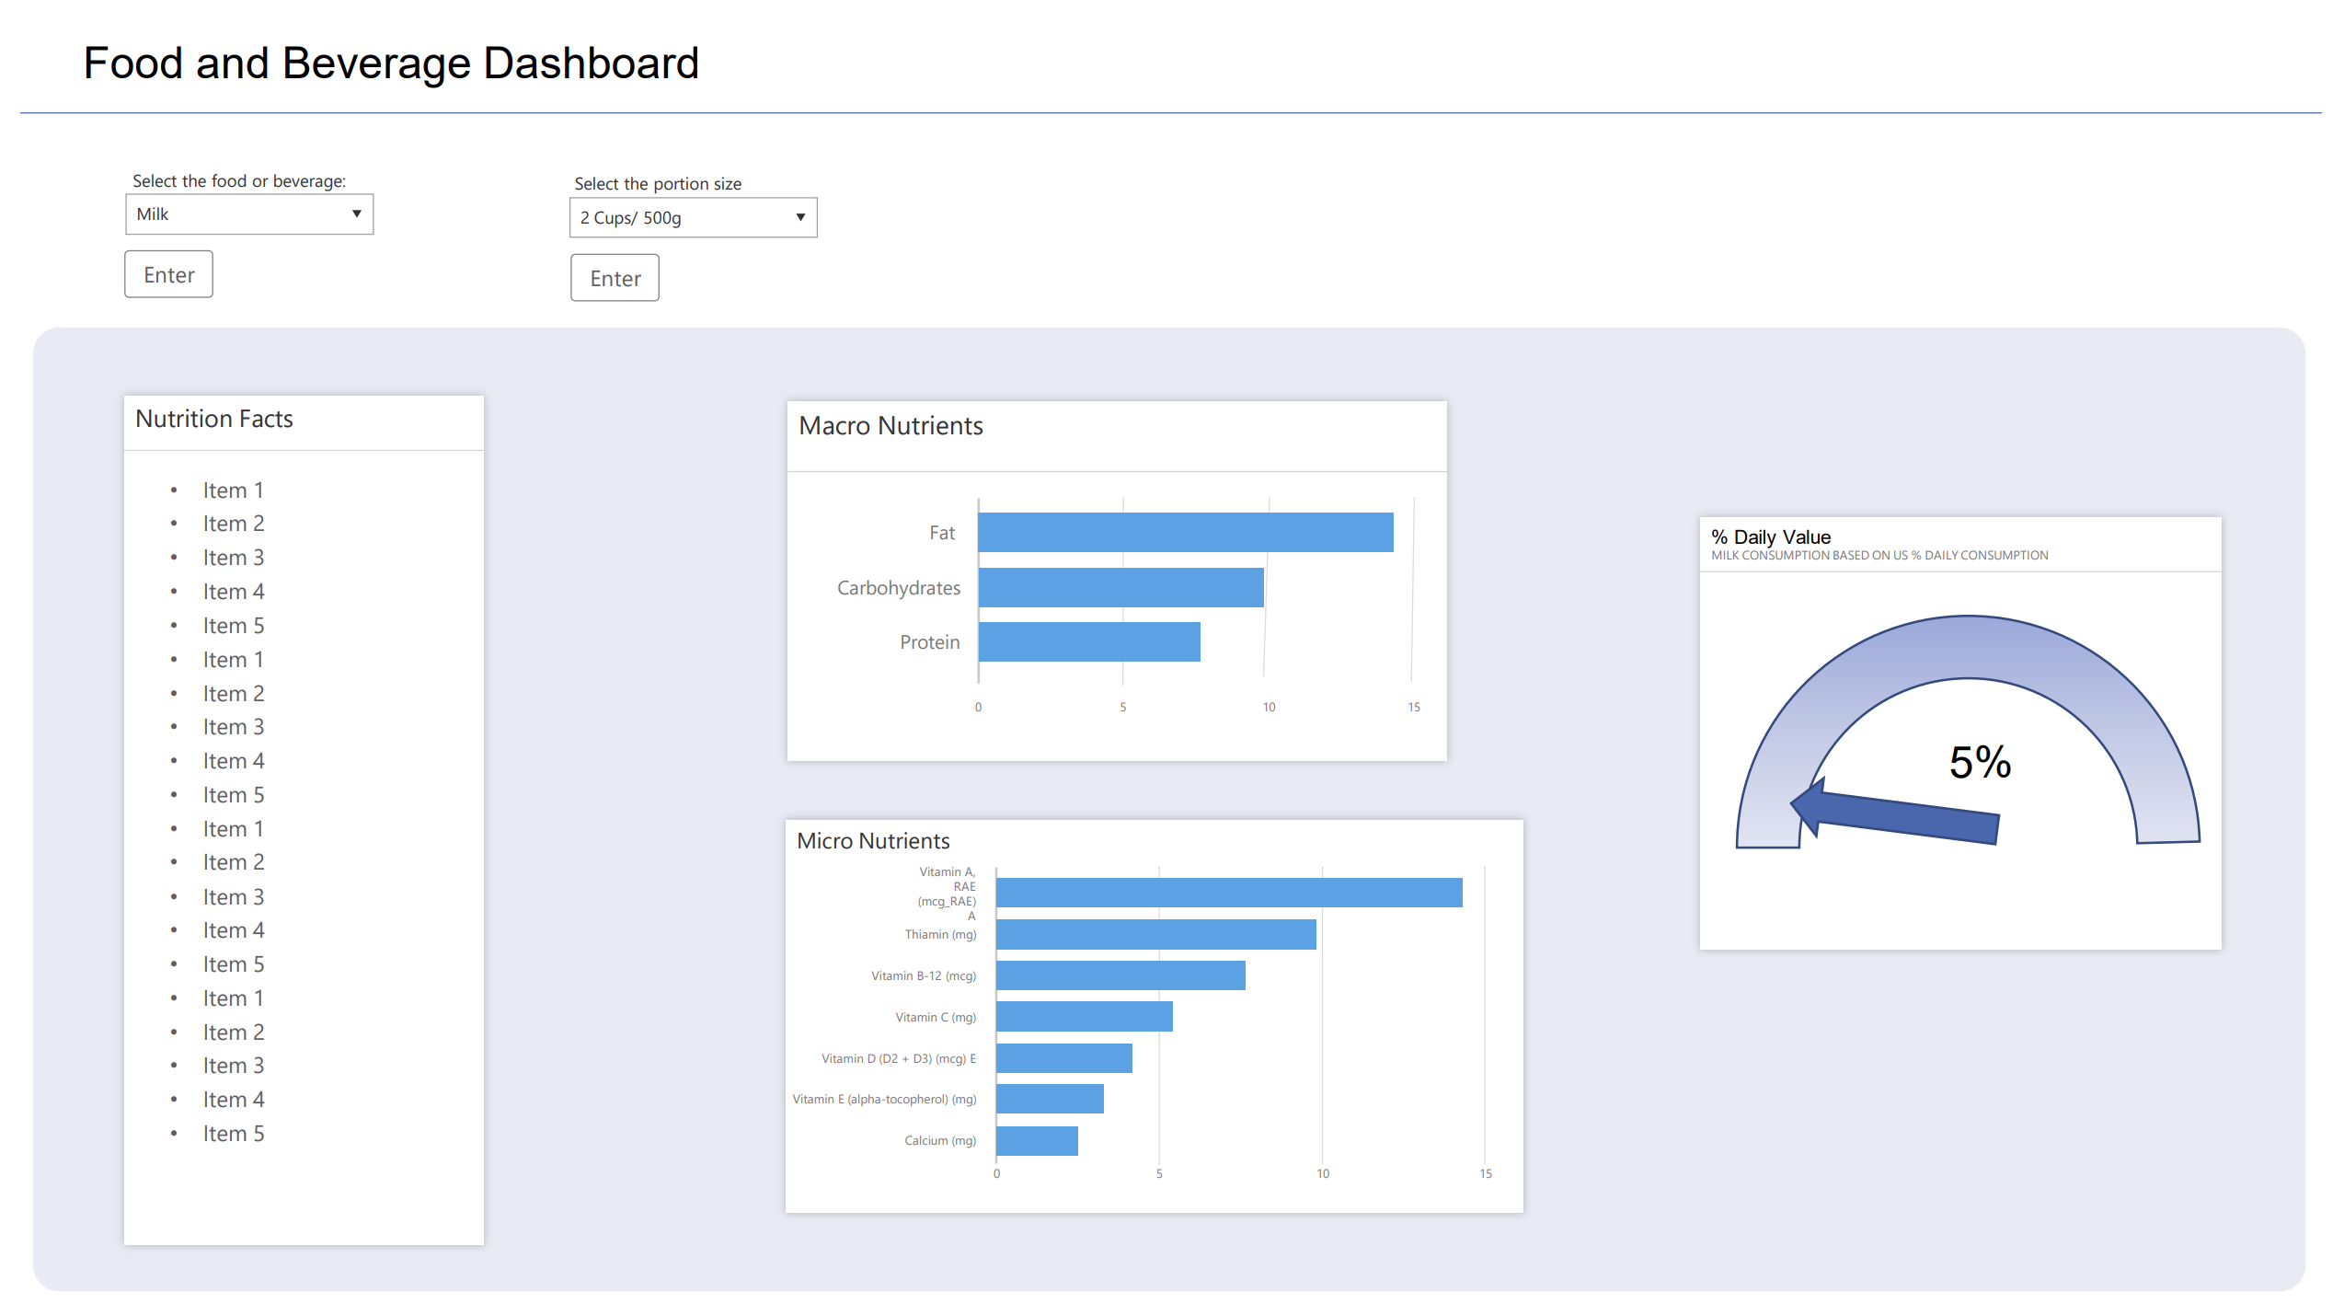

Link to Project 2 GitHub Repository:

<https://github.com/jmitterh/group_project_2>